## APIs – Proof of concept

This document contains information about the APIs we will use in our application: for each API, which methods will we use from the methods offered by it, how we will use those methods, example of what response it returns, why is it useful for our application .

1. **Getty Images API**

For testing the Getty Images API, the C# Getty Images SDK was used, which is a wrapper over the HTTPClient class usually used for making requests to an API endpoint. I did some calls to the methods we will probably use in our application, such as:

**Search images method: api_endpoint_url/search/images**

This method is very complex. You can search images by a phrase and you can filter that search by many things. The most relevant filters are probably:

* **color –** filter based on predominant color in a image
* **fields -** Specifies fields **to get in the answer** – the most relevant ones: **caption, display_set (** this returns the available picture sizes with they’re uri’s to possibly include in the application – ussualy will return uri’s of: **comp, preview and thumb sizes) - you can also filter by comp, preview, thumb if you only wish to get one of the sizes, keywords –** a list of keywords associated with a image, **id** – the id of the image, **title** - the image title
* **keyword_ids** - Return only images tagged with specific keyword(s). Search by a phrase and filter by keywords (tags).
* **page , page_size** – we will need this for pagination, to not get all the answers at once
* **sort-order** – best-match,most popular or newest
* **age_of_people** - filter based on the age of individuals in an image.

The SDK also allows to filter by where the images was taken (location)

Examples of calls and images returned:

**Phrase: summer ; Fields: id, title, keywords, display_set; Sort-order: best_match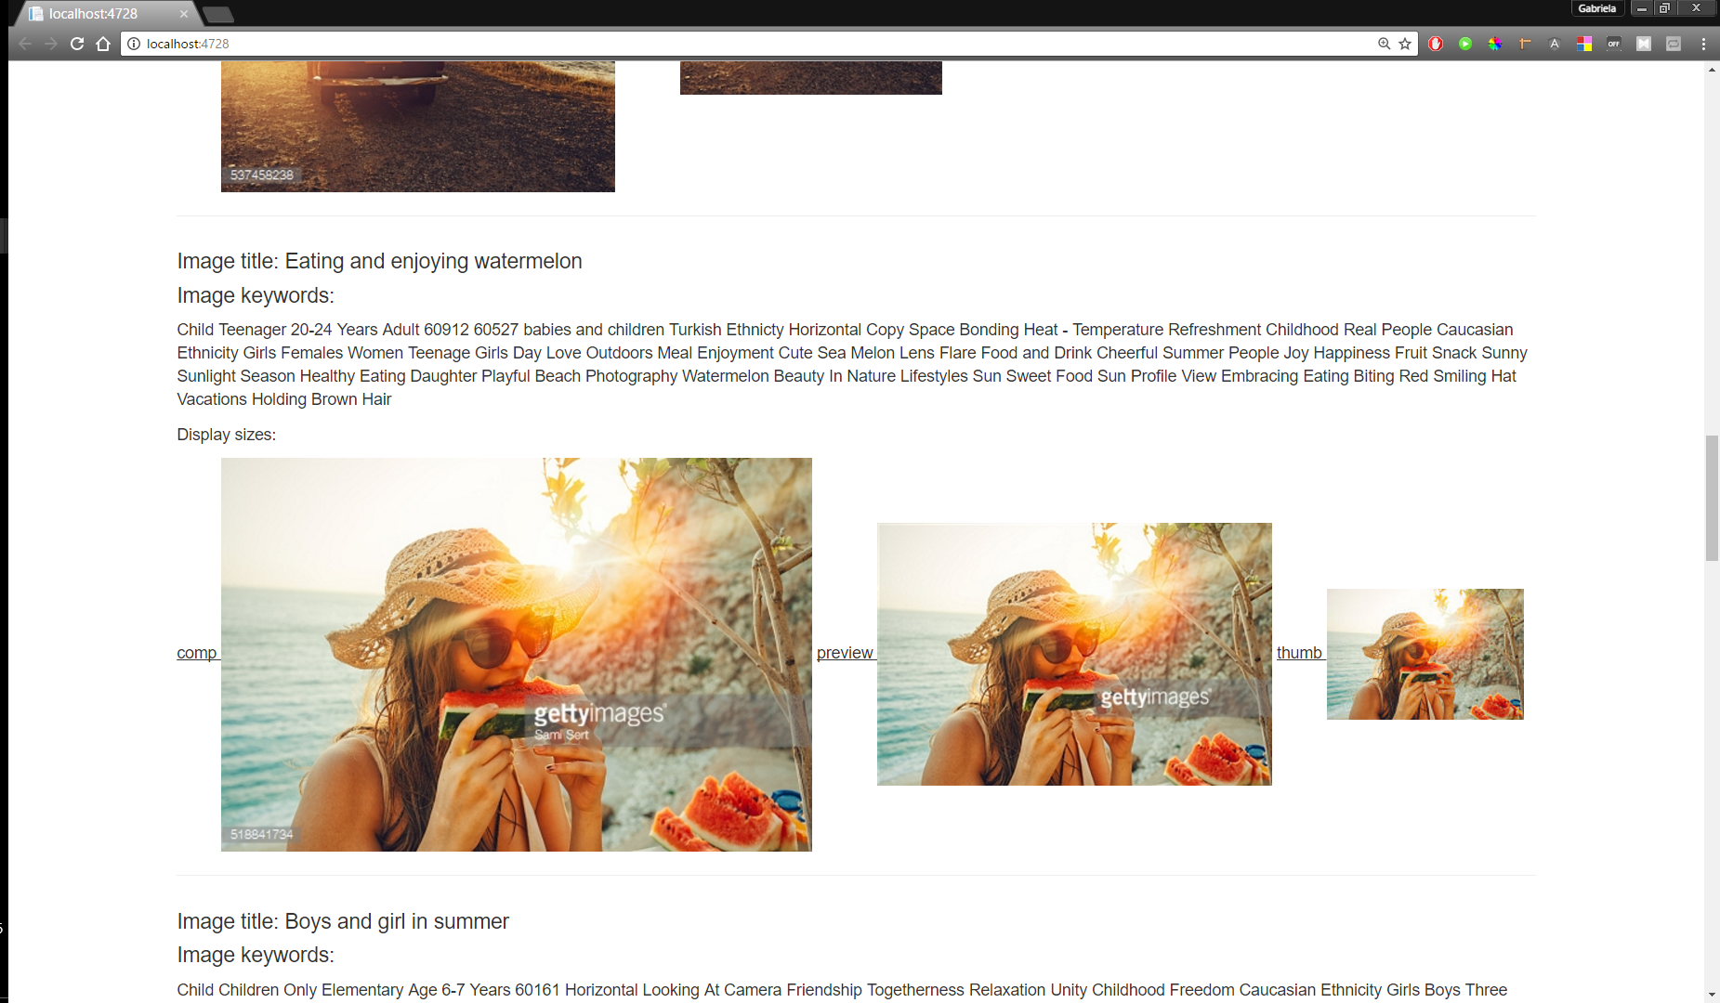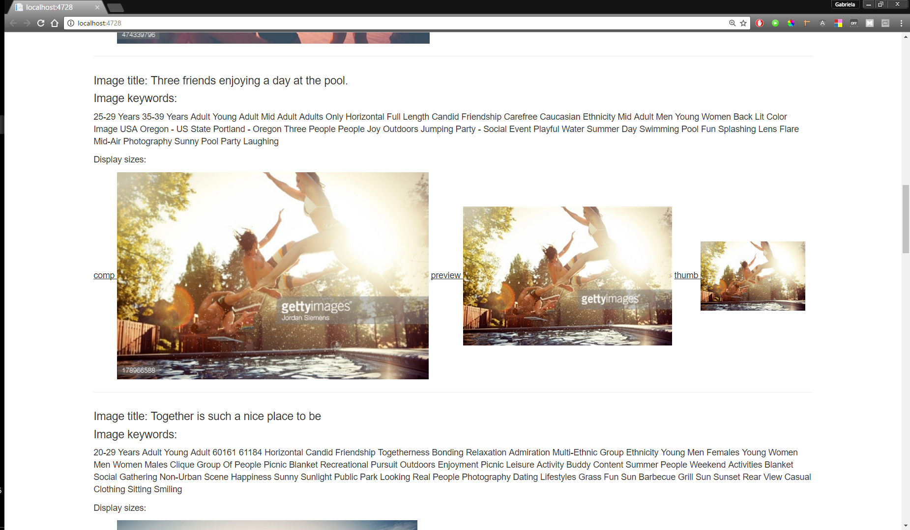Phrase: winter, Comp (**as images size**), location:China, Age_of_people: baby, Sort-order: best_match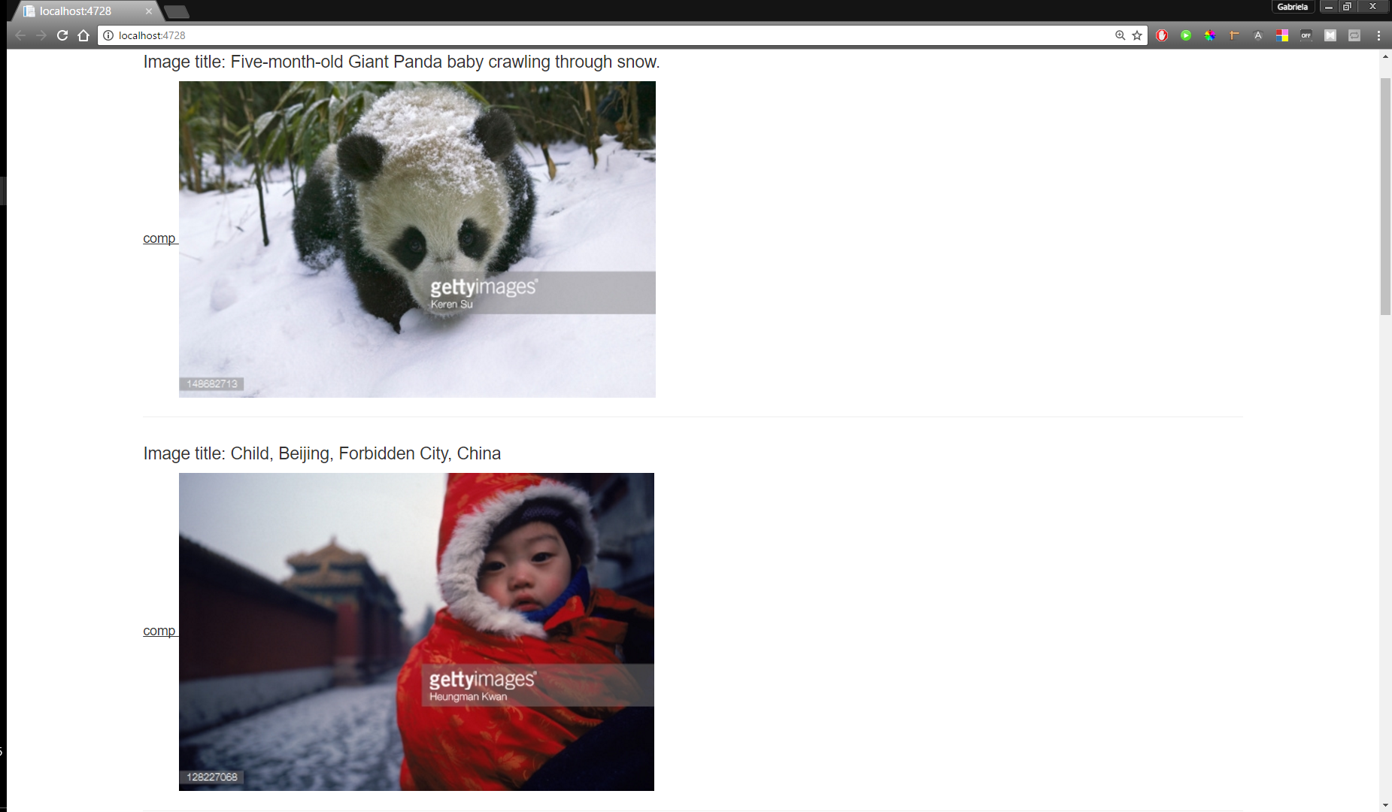Phrase:elections , Specific_people: Trump**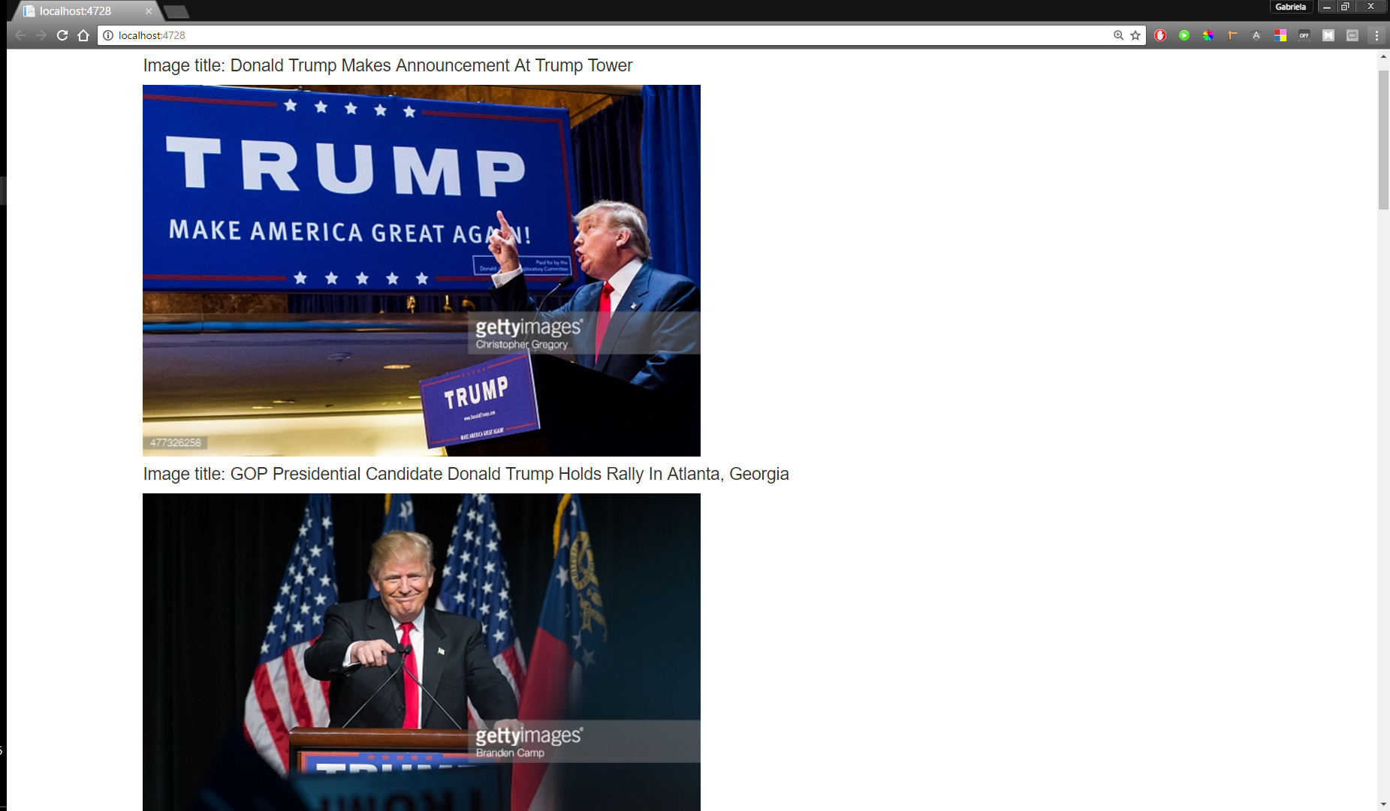

Phrase: autumn, Keywords: 60027(Cold temperature) y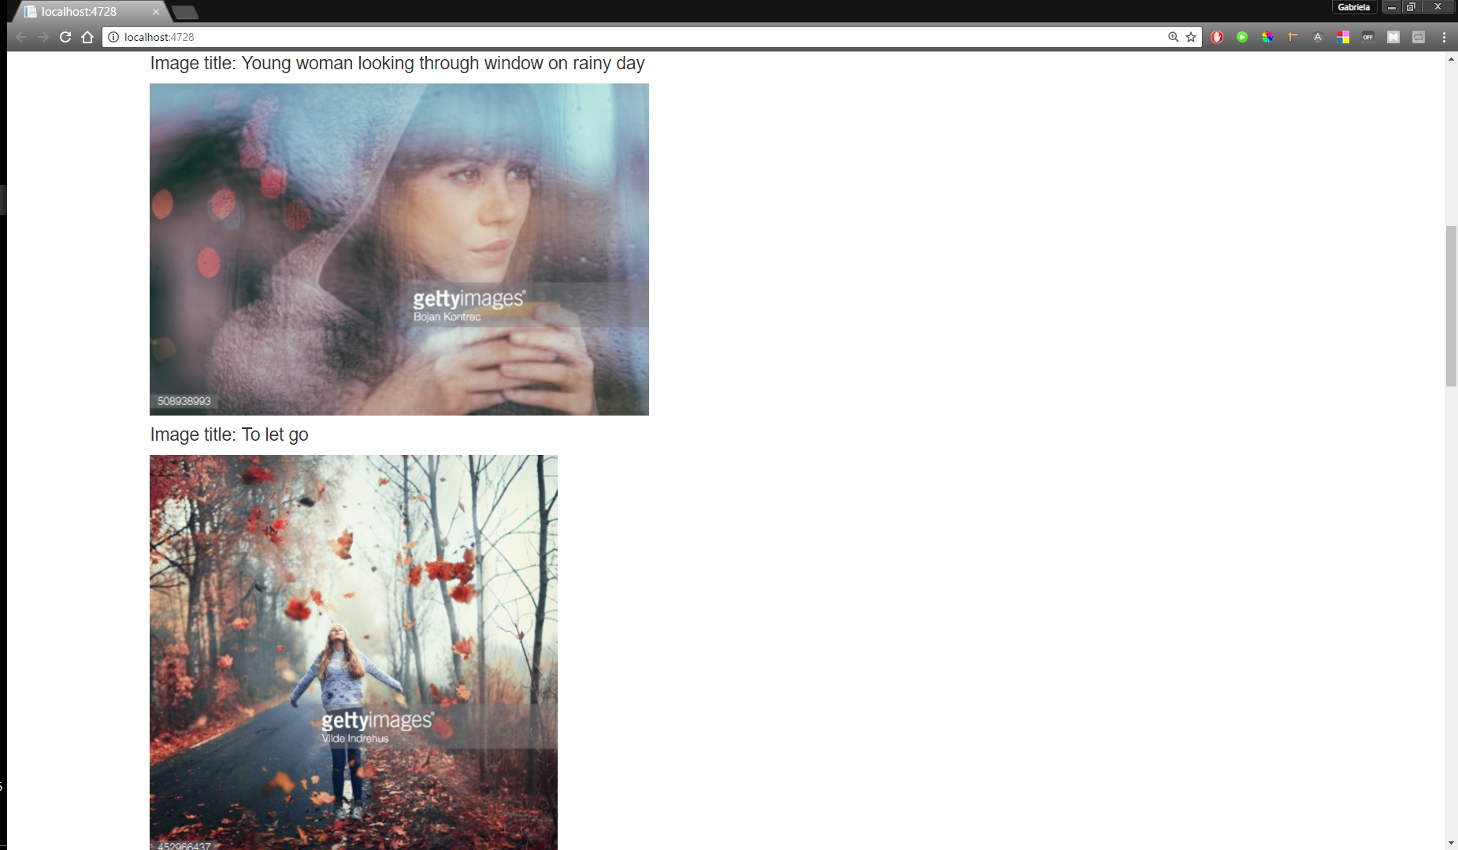Phrase: summer; Color: #0000FF (blue)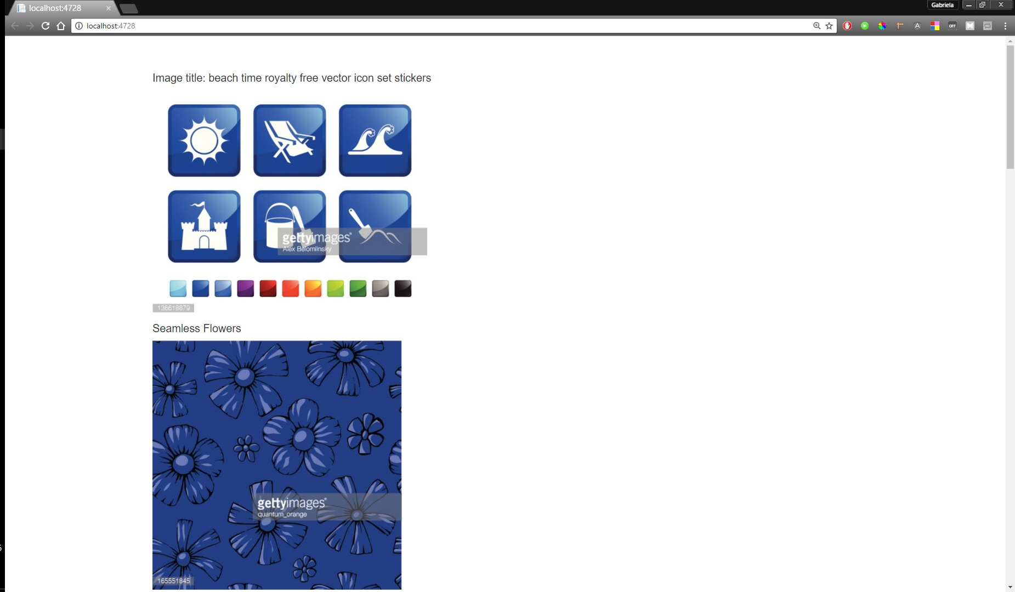

Similar images method: **api_endpoint_url/images/id/similar – we could use this method in our application, but I could not figure out why all the calls to that method give an Unauthorized message as response.**

1. **Flickr API**

For testing the Flickr API, we used Flick4Java, developed in Java language, which is a very usefull REST based API, because you can get images from Flickr, classified by many criterias, using the wrapper classes it contains.

**Search images method: flickr.photos.search**

The search endpoint allow user to get images by specifying many parameters like:

* “text”: a description used when a photo is posted;
* “tags”: a set of tags, used to group many photos with same characteristics;
* a location (by “latitude”, “longitude”, and “accuracy”): where the photo was taken; the accuracy parameter is used to specify the location information (world:~1, country: ~3, region: ~6, city: ~11, street: ~16) ;
* “perPage”, “page”: the number of photos returned per page and the page offset;
* “safeSearch”: the safe level of the results (1 – safe, 2 – moderate, 3 - restricted).

Examples:

1. 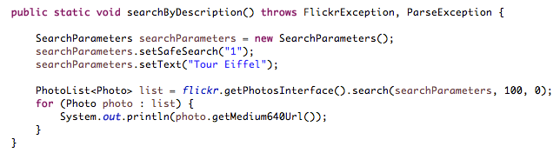Search by description (search photos with Tour Eiffel):

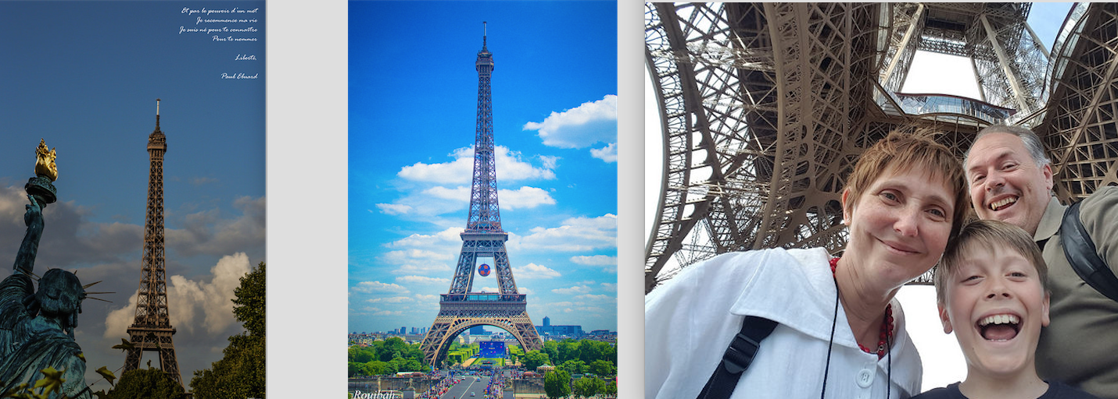

1. 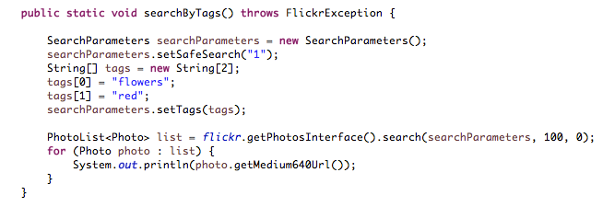Search by tags (search photos with red flowers):

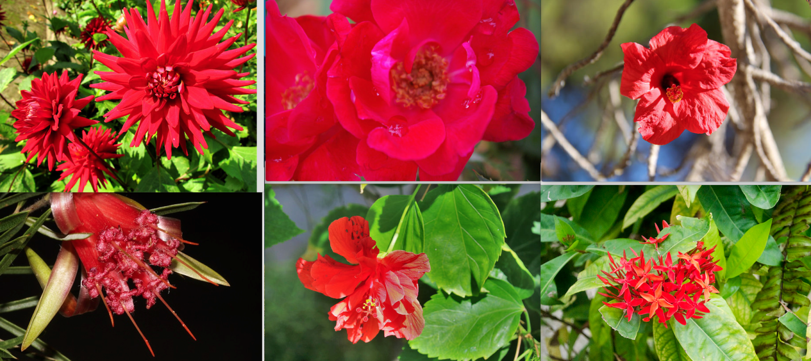

1. 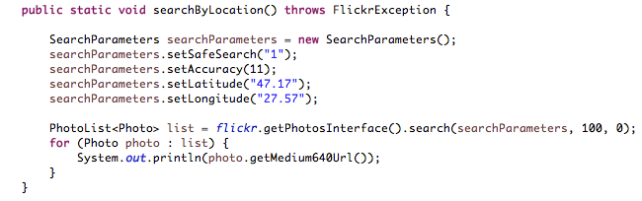Search by location (search photos from Iasi, accuracy level: city):



1. 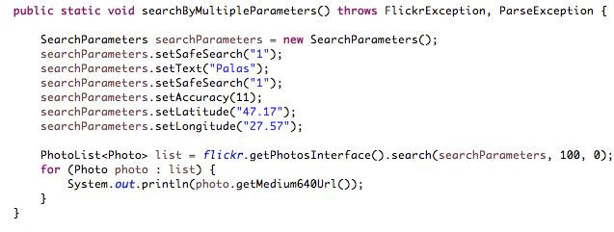Search by multiple criterias (search photos from Iasi, having “Palas” as description ):

